**Assignment 5**

**(CSS)**

1. Design a webpage that uses style sheets as follows:
   1. Make every <B> tag that appears as blue as well italic
   2. Make every <P> tag as justified, italic and with indentation of 1”
   3. Make <H1> tag underlined, uppercase, center aligned and with background color and border
   4. Make <OL> tag to use decimal list style.

Use the following methods:

* 1. Inline Style sheets
  2. External Style sheets
  3. Embedded style sheets

1. Make your time table in HTML. Using CSS, make a class of <TD> tag that is of red color and another class of blue color. Use these tags in your table. Headings should be darker in each column.
2. Create a web page similar to the web page shown below (Using inline style sheet for h1 and internal style sheet otherwise)

H2

H1

paragraph

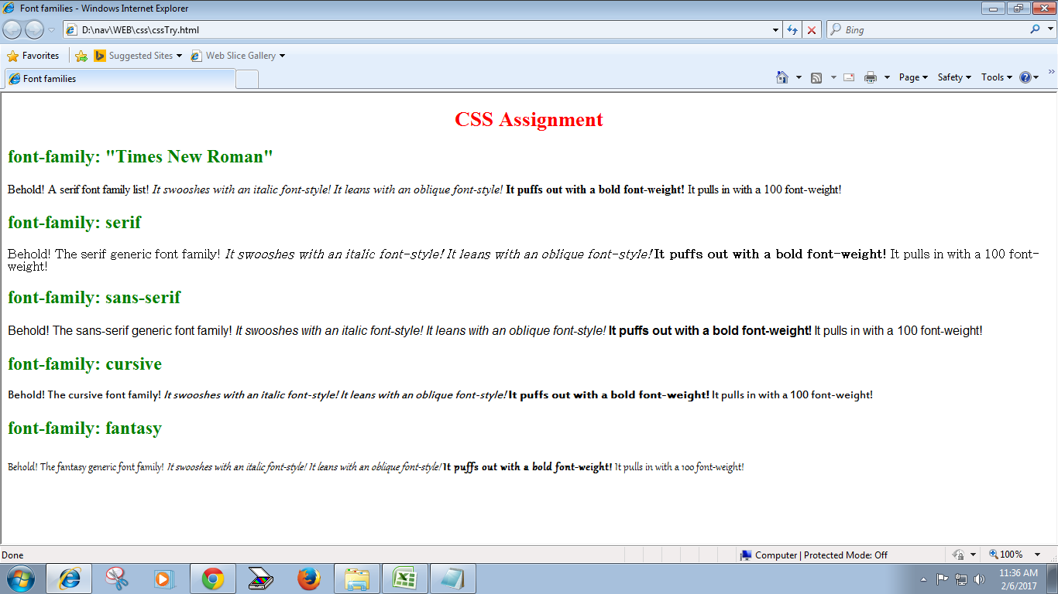

1. Create a web page similar to the web page shown above (Using inline style sheet for h1 and external style sheet otherwise)